Hello Bandits….
Hope everyone is staying healthy. It’s Ms. Saldivar (Art Teacher).
I have a fun art activity for you all.
The activity is something all of you can do from within your home, safety First.
The lesson is for you all to use objects or things that you already have from home. You will create a color wheel using the colors of the rainbow (red, orange, yellow, green, blue, and purple). You can use ANYTHING that you find within your home.
When you are done, take a picture of it and send it to me on the Burns Website, under School Clubs Art. Attach your picture to a Word Document, with your Name, Teacher, Grade, this way I can give you credit for your work. Don’t forget to click submit! Otherwise I won’t get your assignment.
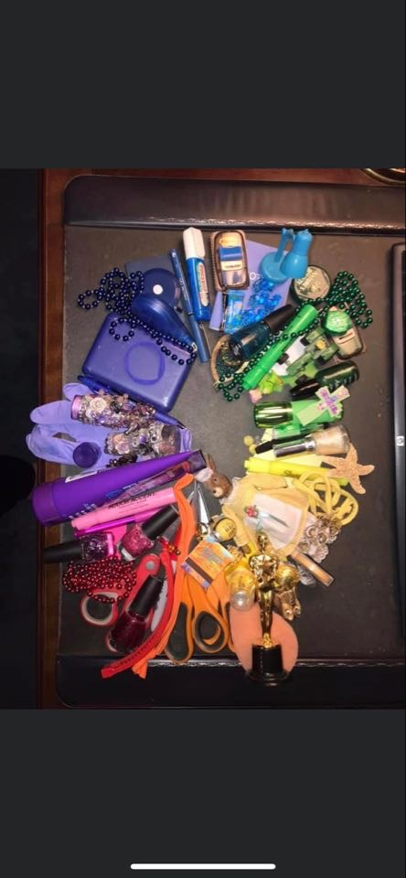
Thanks , Have Fun and Get Creative!!!

